CAOS project

Adrian Tang
Teo Xue Ting

Lecturer: Mr Boey Chee Kin

1. INTRODUCTION
A. Project Description
The aim of this entire project is to apply the CPU scheduling algorithms into real coding. Our group had put in a lot off effort to developed an application that can simulate CPU scheduling under 3 different algorithms. These 3 main algorithms are First Come First Serve, Shortest Job First Non-preemptive and Worst Fit Method.

B. Task Breakdown
Xue Ting | - FCFS  - Worst Fit  - Console Design
Adrian | - Non-preemptive SJF  - Integration  - Worst Fit  - Console Design

2. Theoretical Background
The program was created by Eclipse and displayed in a console mode with the following objectives:
- create and store processes, arrival time, burst time and turn around time with their size
- schedule CPU allocation to the stored processes via first come first serve algorithm and display these data such as average waiting time and average turn around time in a console mode
- managing memory allocation by allowing the creation of memory partitions and allocation of the processes to them using Worst Fit

3. Software Design
Main menu of the console program
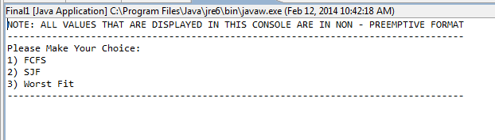
FCFS algorithm
- prompt user to enter number of processes they wanted
- prompt user to enter burst time for each of the processes
- prompt user to enter arrival time for each process
- display arrival time, burst time, waiting time, turn around time, average waiting time and average turn around time of each processes
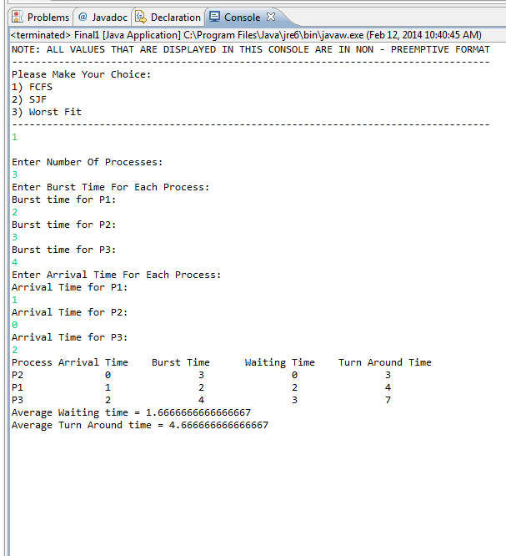

Non-preemptive SJF
- prompt user to enter number of processes they wanted
- prompt user to enter burst time for each of the processes
- prompt user to enter arrival time for each process
- display arrival time, burst time, waiting time, turn around time, average waiting time and average turn around time of each processes
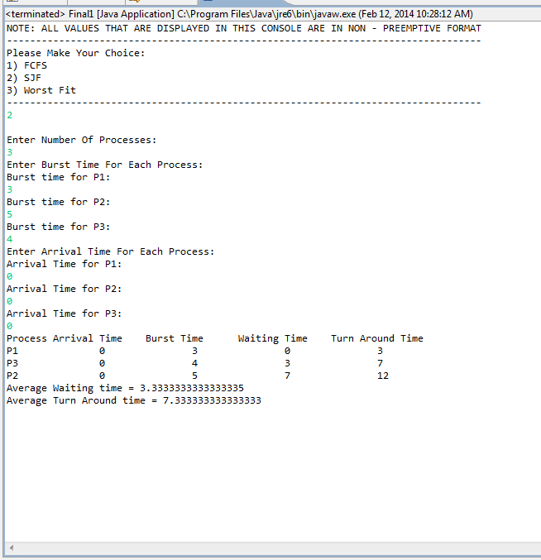

Worst-Fit
- prompt user to enter number of memory blocks
- prompt user to enter number of processes
- prompt user to enter the size of each block
- prompt user to declare which of these blocks are used
- prompt user to enter process demand of each process
- display number of blocks used, total used space, free blocks and total free space
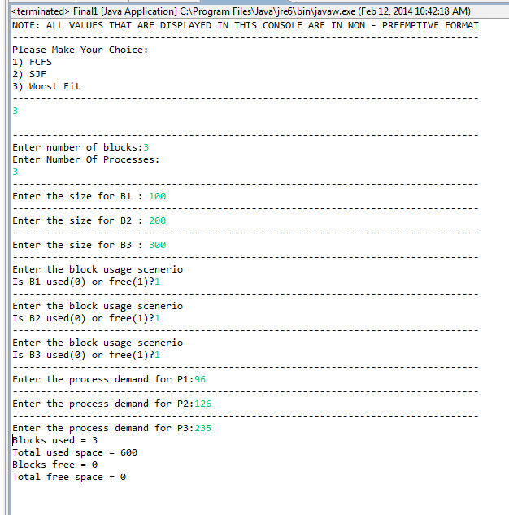

4. Conclusion
Our team has only developed two of the enquired simulation systems in first come first server and non-preemptive shortest job first. The team had one integrated console consisting of first come first serve, non-preemptive shortest job first and worst fit in console mode.

Only two out of the three programs are functional and our team members did not really cooperated well to complete the entire project.

